GROOMING CHECK-IN FORM
Pet’s Name: ___________________Last Name: ______________________ Date: ________
Phone #: _______________________ Today’s Service: Bath ⎕ Groom⎕

GROOMING: Please select scheduled appointment time below.
⎕ 8:30AM--Pick Up 2PM ⎕ 11:30AM—Pick Up 4PM ⎕ 1:30PM—Pick Up 5:30PM

*Instructions for Groomer: ____________________________________________________________________________________________________________________________________________________________________________________
Bath: Requested pick-up time: ___________**This is not a guarantee, but we will do our best. Please wait for our phone call, to confirm your dog is ready to go home!
Please select additional services below, if desired. These charges will bee added to your bath/groom at the time of pick-up.
Spa Package: $15 Classic Add-Ons
Includes premium scented shampoo & cologne, teeth brushing, paw balm, & conditioner.  ⎕ Lavender  ⎕ Blueberry  ⎕ Juniper  ⎕ Apple  ⎕ Oatmeal  ⎕ Gentleman  ⎕ Flea/Tick  ⎕ Whitening  ⎕ Hypoallergenic  ⎕ Medicated | 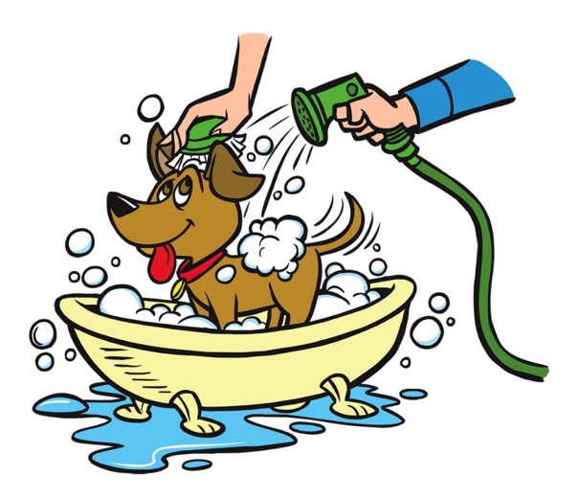 | ⎕ Teeth Brushing: $10  ⎕ De-Odor Shampoo: $20  ⎕ Paw Balm: $5  ⎕ Premium Scent  (includes conditioner): $7
*I understand by having my dog bathed or groomed at Rocky Creek Veterinary Hospital & Pet Resort, I agree to the Grooming Policies & Procedures, which can be viewed at www.rockycreekvet.com.
*I understand, if my dog has to be de-matted by brushing or shaving, I may be charged a mat removal fee based on severity. If the mats are too severe to be brushed out, I understand my dog will have to be shaved down. I also understand, if I refuse a shave down due to matting, I must take my dog home as is, without a bath or haircut.
Client Signature____________________________________________Date________________
THERE IS A $50 LATE FEE CHARGE FOR ANY PATIENT PICKED UP AFTER 6:00 PM!

